**Linux**

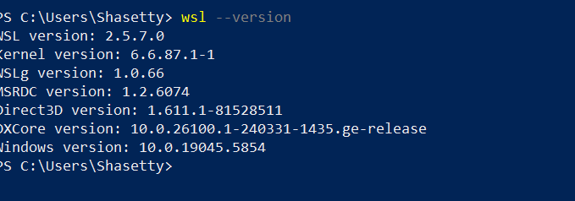

**TASK - 1**

Create a Directory with the Name Linux Practice.

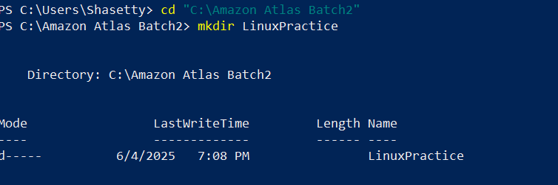

**TASK - 2**

Change to the directory

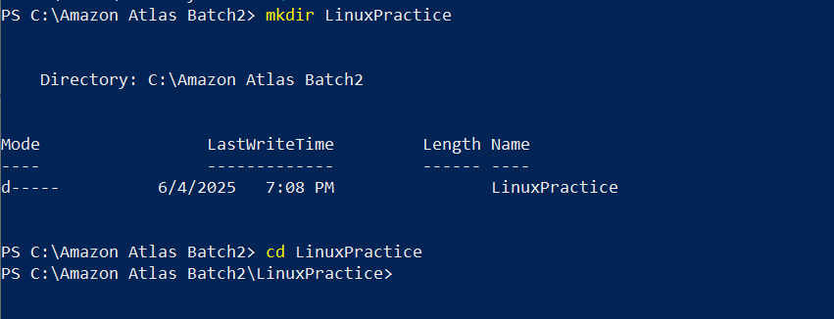

**TASK - 3**

Create a file name TestFile1.txt and add the content to it.

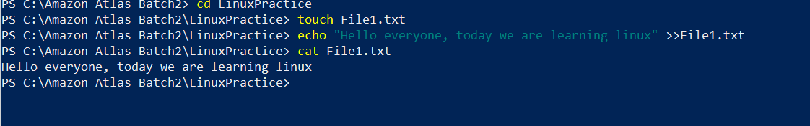

**TASK - 4**

Create a Folder named Dummy and try to delete it.

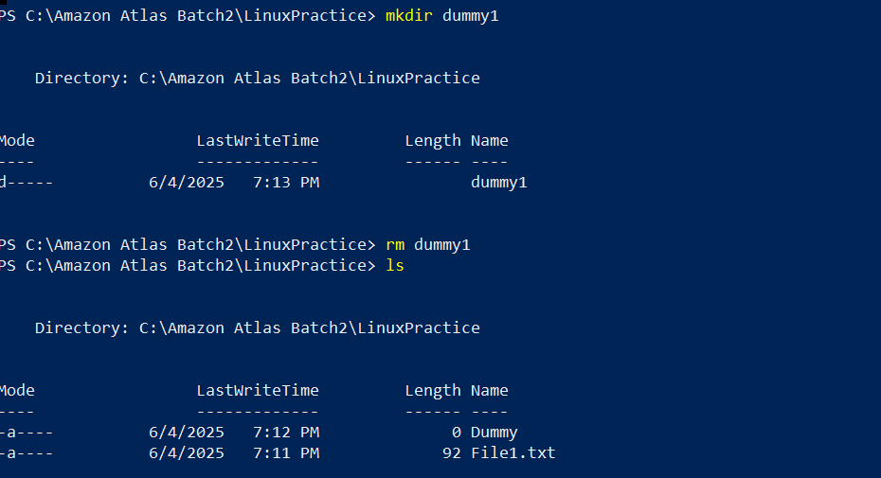

**TASK - 5**

Plz check the working directory (Hint : pwd)

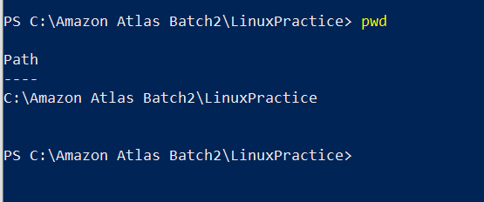

**TASK - 6**

How do you check all the files and directories in the directory you are in?

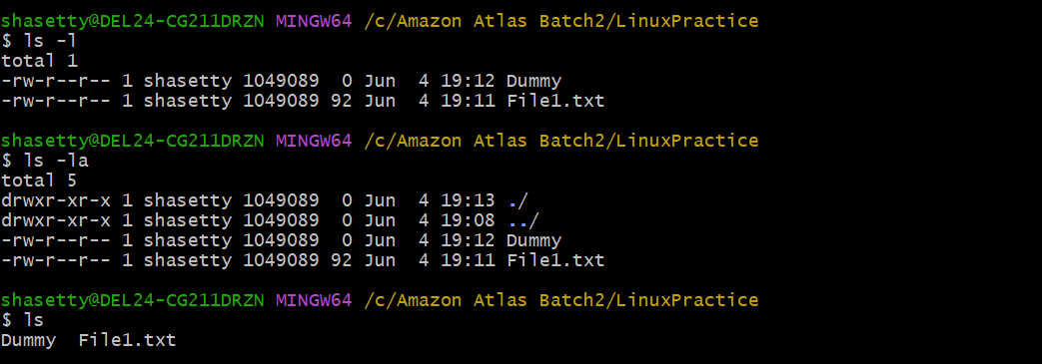

**TASK - 7**

Create five files named TestFile2.txt.. TestFile3.txt… and so on till TestFile6.txt

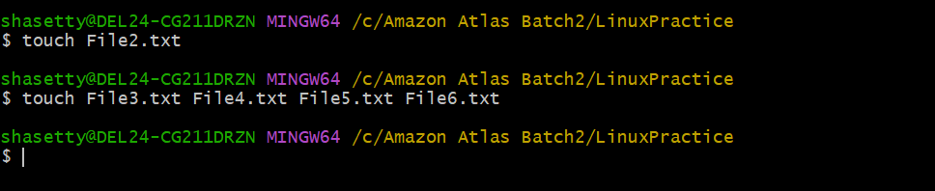

**TASK - 8**

Copy all files from Dir 1 ti Dir 2

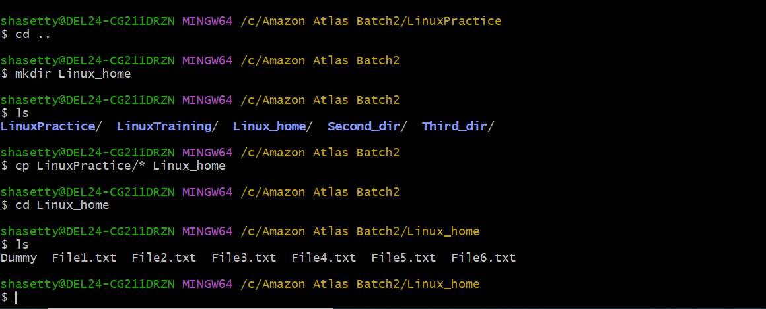

**TASK - 9**

Move all files from Dir 2 to Dir 3 (finally ur Dir 2 should be empty)

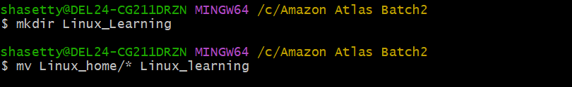

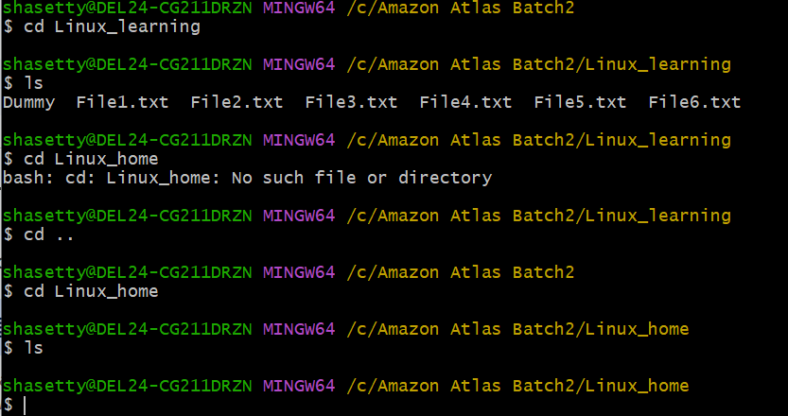

**TASK - 10**

Can you plz show me the diff between **rm** and **rmdir** commands with screen shots ?



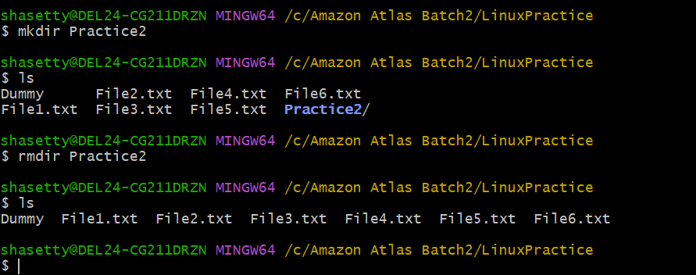

**TASK - 11**

Now use specifically use cat command to create a file

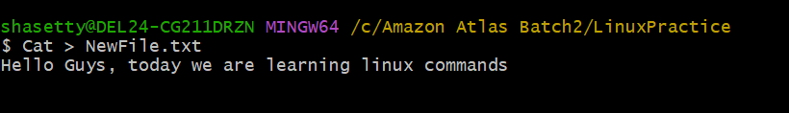

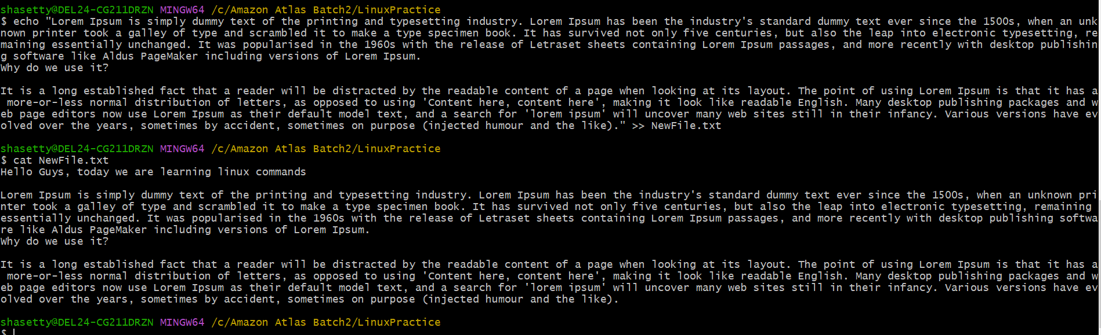

**TASK - 12**

How to get only the top part of your file..

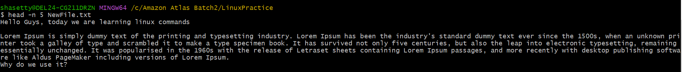

**TASK - 13**

How to get only the last part of your file

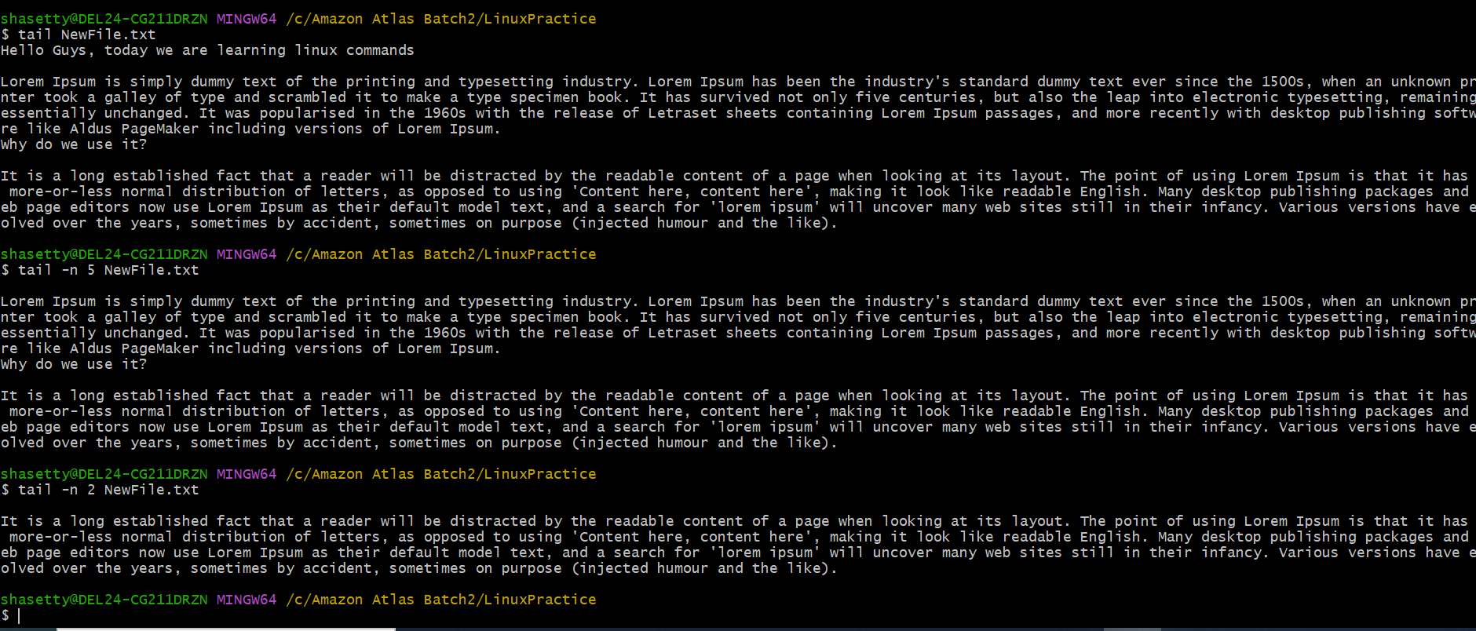

**TASK - 14**

Plz add dummy text of 5 to 6 pages in to the same file

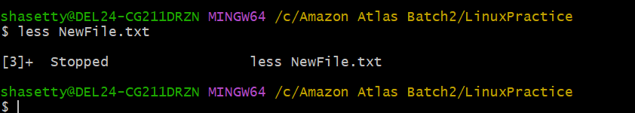

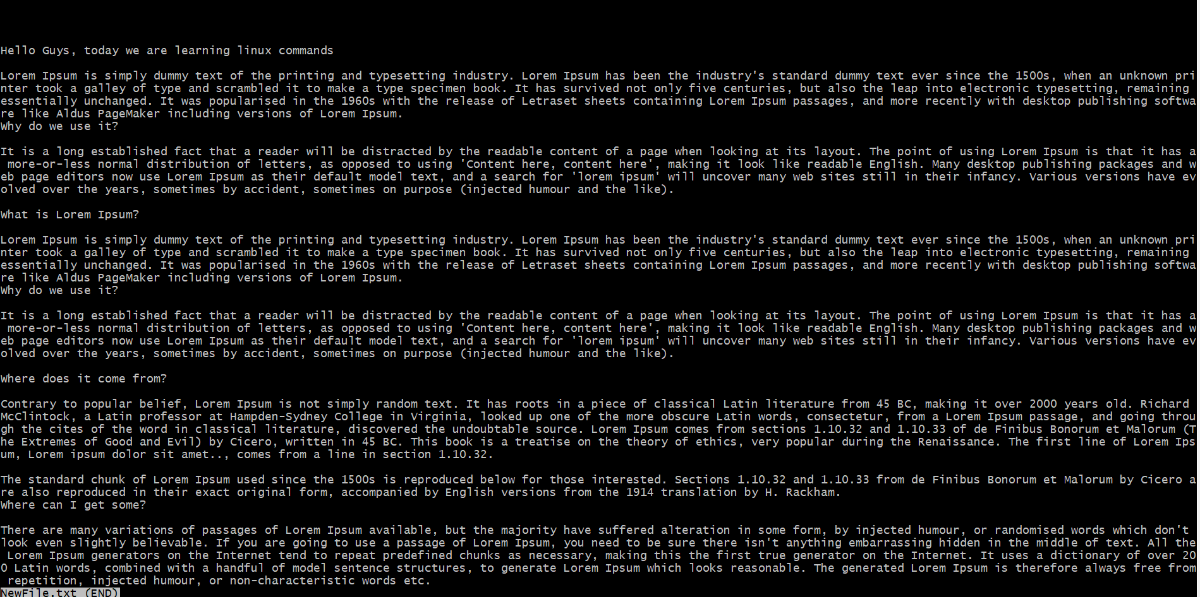

**TASK - 15**

Use more command on the above file and find out the diff between less command and more command.

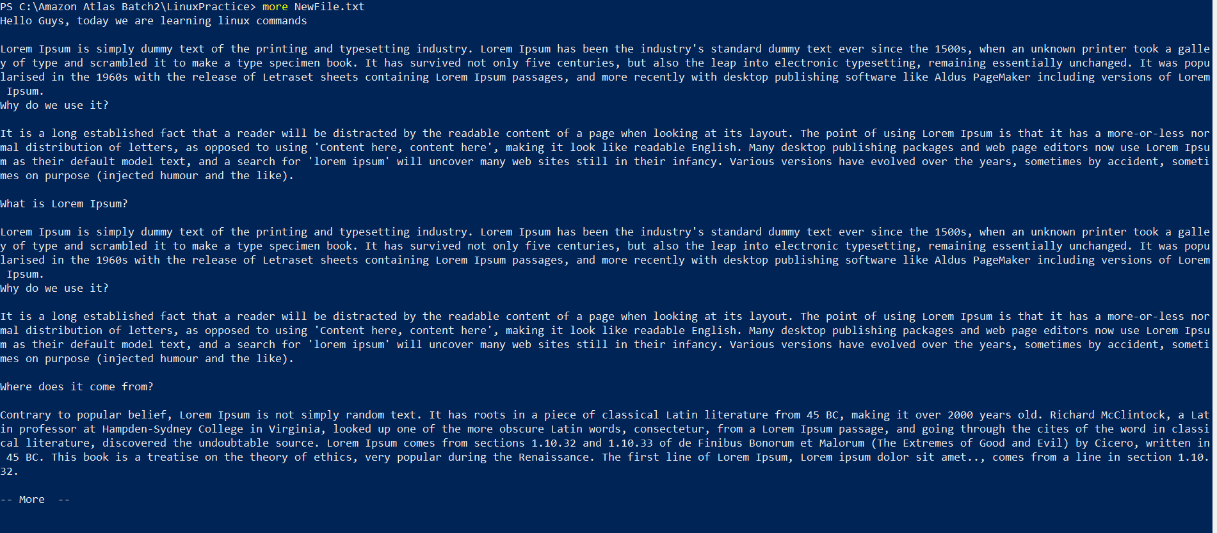

**TASK - 16**

Can you use echo command with -e and see the diff.. Also take a ss and paste .

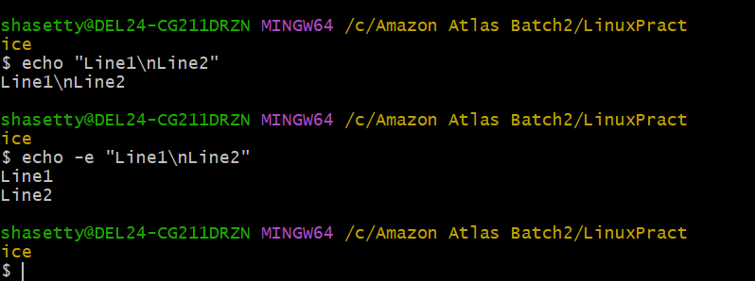

**TASK - 17**

What is diff between ls and ls -l command .. ss plz

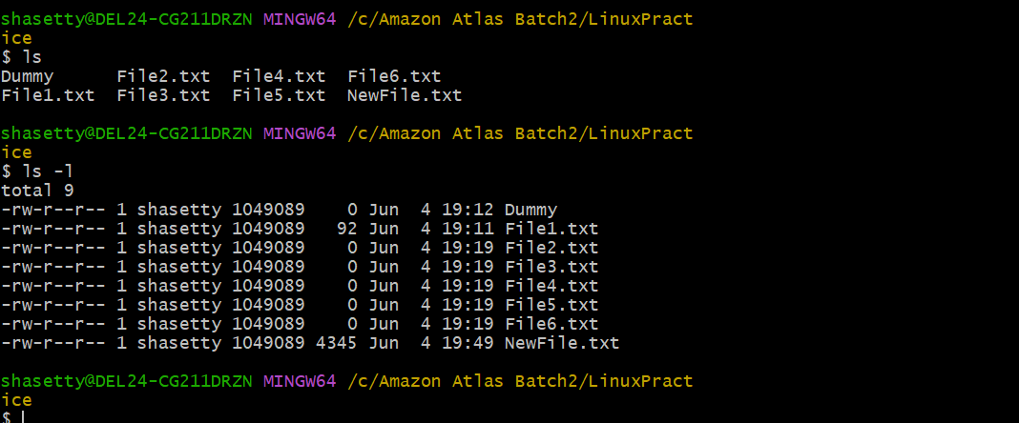

**TASK - 18**

Create a file using **touch** command , **cat** command and **echo** command and take ss (screen shot)..

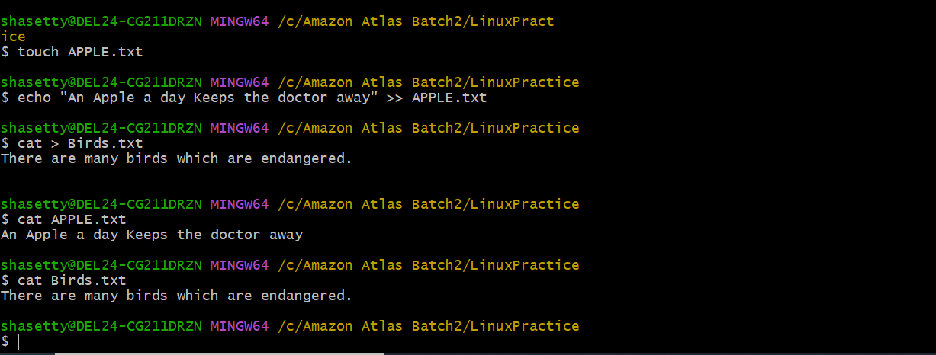

**TASK - 19**

Can you guys try to display the calendar by using a command..

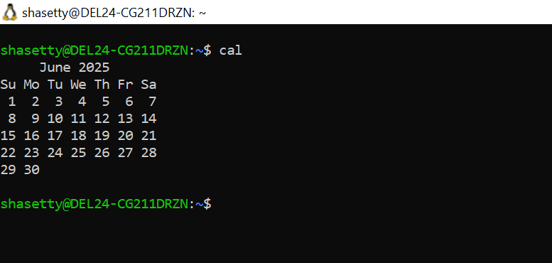

**TASK - 20**

Can you go back to 1 directory .. at a time whats the command

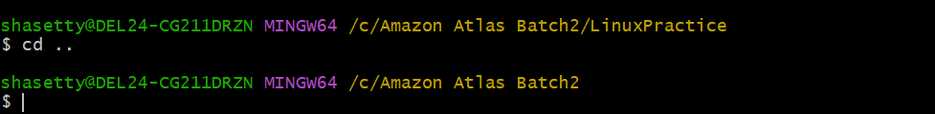

**TASK - 21**

How to know whose user u are working on ?

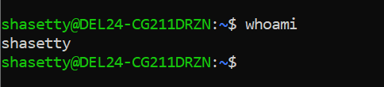

**TASK - 22**

Try to find out who is peeping into your system..

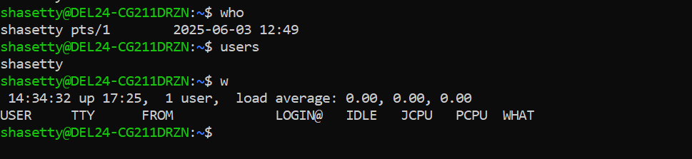

**TASK - 23**

Can you guys try to check how much disk space is consumed..

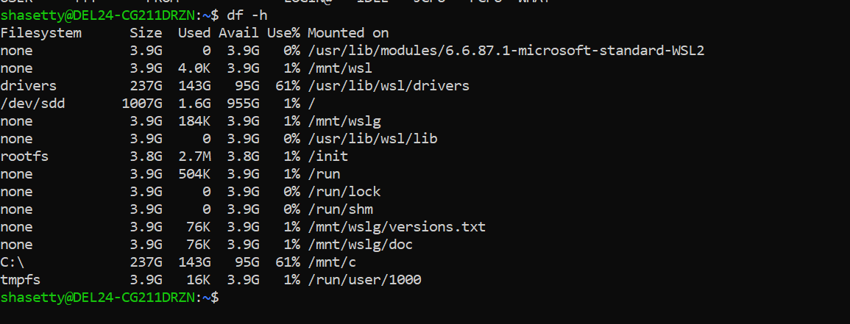

**TASK - 25**

Find the list pf all files ending with .txt

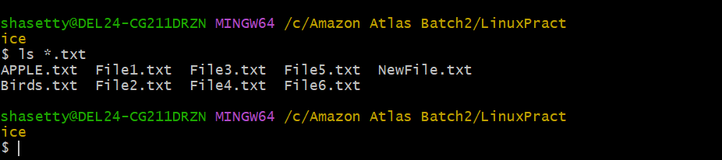

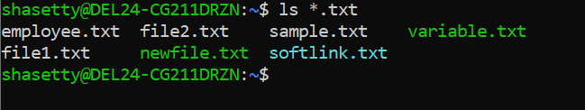

**TASK - 26**

In Linux all the hidden files starts with . (period)

How to check all the hidden files in Linux..

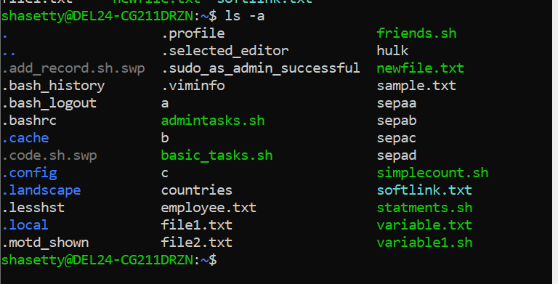

**TASK - 27**

What is the difference between . and .. in linux

### Single Dot- Represents the current directory

### Double Dot - Represents the parent directory (the directory one level above)

**TASK - 28**

Can you create a file using vi editor and show the details in ss

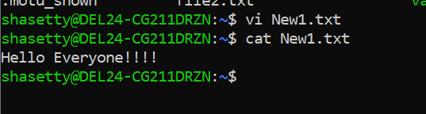

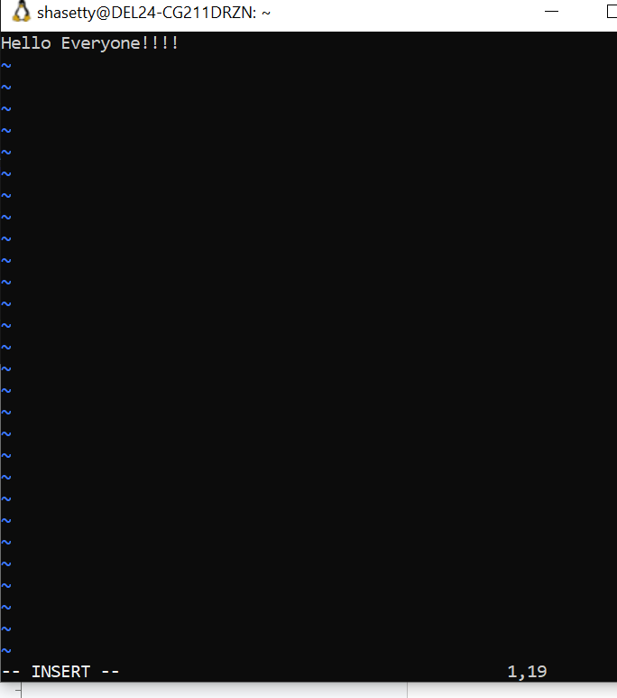

**TASK - 29**

How to find the no of words in the file

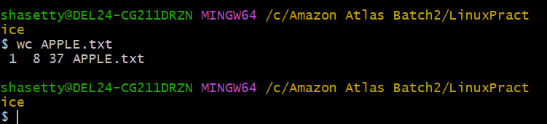

**TASK - 30**

What is the use of cat -b myfilename.txt command?

* **used to display the contents of myfilename.txt with line numbers, but only for non-blank lines.**

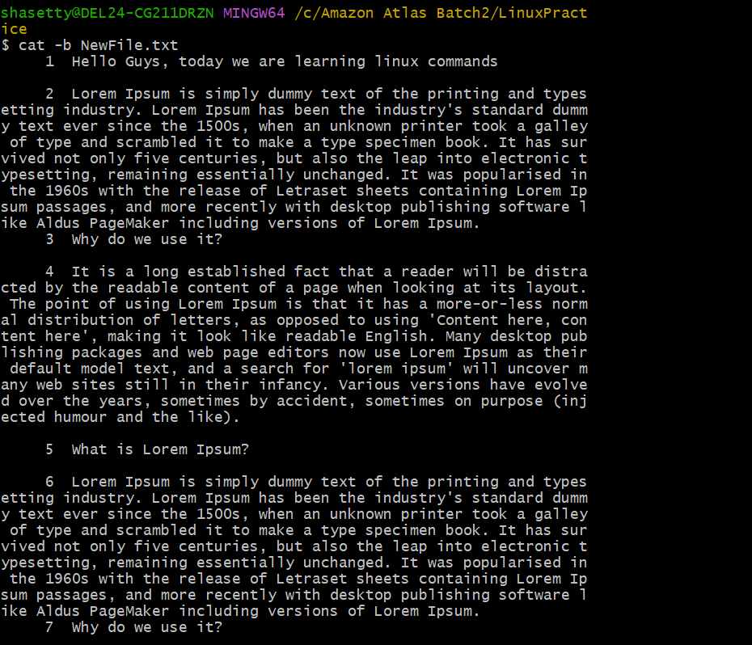

**TASK - 31**

Can I use the wc with 2 or more files?

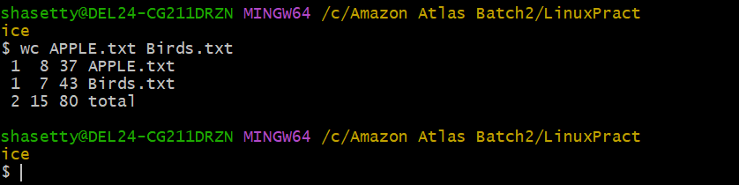

**TASK - 32**

How to copy content of one file to another file

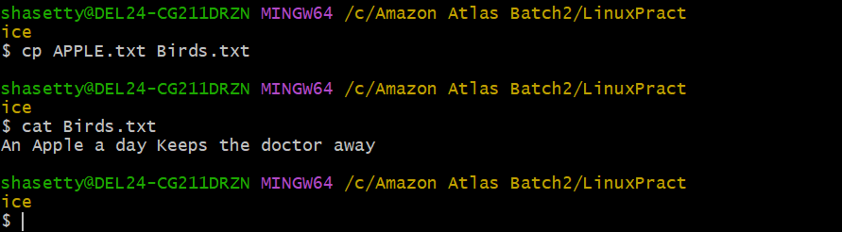

**TASK - 33**

Now I want to rename my file with MYFILENEW can i do that if so how ?

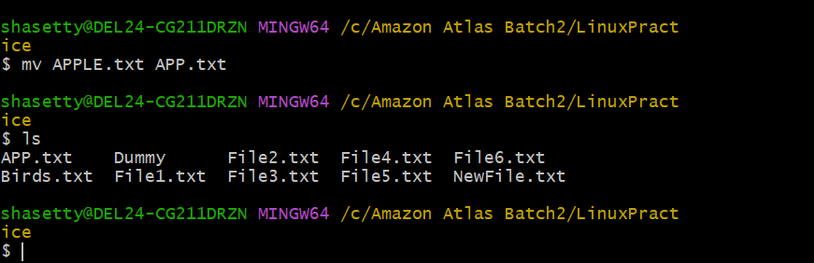

**TASK - 34**

Can i remove or delete multiple files in linux..? How?

**⇒ rm File1.txt File2.txt File3.txt**

**= rm *.txt**

**TASK - 35**

In directory / slash is root … can you try cd / what is it doing?

* **It changes your current working directory to the root directory.**

**TASK -36**

What is the way go go to home directory ?

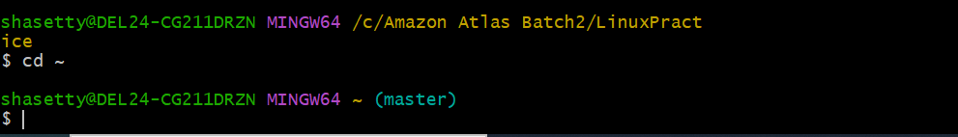

**TASK - 37**

If i want to move to different users home directory

